11-04-2023 ASSIGNMENT 1 OOPS WITH C++

Print the numbers and character variables, we use the same cout object but without using quotation marks.

Answer:

#include <iostream>

using namespace std;

int main() {

int num1 = 70;

double num2 = 256.783;

char ch = 'A';

cout << num1 << endl; // print integer

cout << num2 << endl; // print double

cout << "character: " << ch << endl; // print char

return 0

}

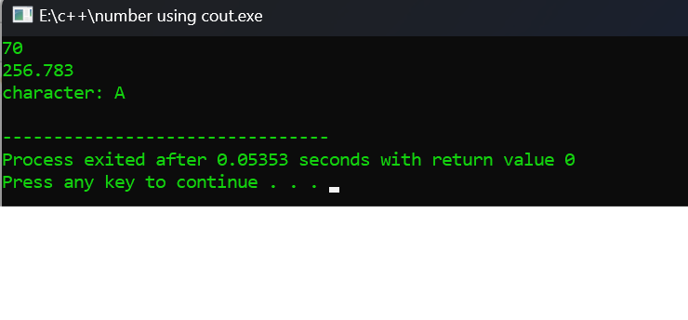

1. Print the numbers by taking input from keyboard using cin object.

#include <iostream>

using namespace std;

int main() {

int num;

cout << "Enter an integer: ";

cin >> num; // Taking input

cout << "The number is: " << num;

return 0;

}

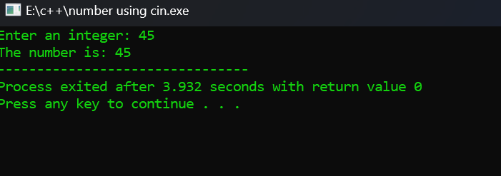

3. Write a program in c++ by taking multiple input from keyboard using cin object and cout object.

#include <iostream>

using namespace std;

int main() {

char a;

int num;

cout << "Enter a character and an integer: ";

cin >> a >> num;

cout << "Character: " << a << endl;

cout << "Number: " << num;

return 0;

}

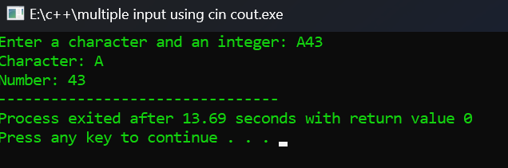

4. **Check if a number is even or odd.**

#include <iostream>

using namespace std;

int main() {

int a ;

cout<<”Enter the number:”;

cin>>a;

if(a%2 == 0) // if remainder is zero then even number

cout<<”even”;

else cout<<”odd”;

return 0;

}

OUTPUT:

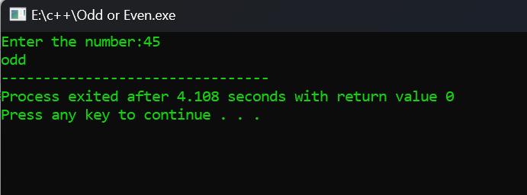

5. find error in this program  
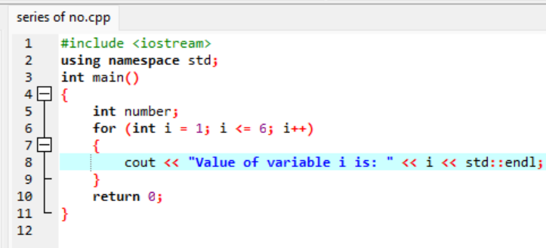

OUTPUT:

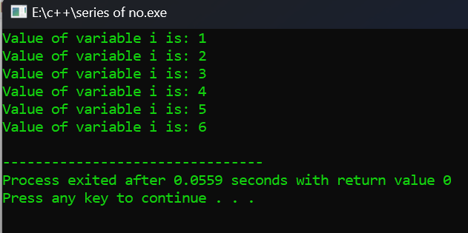

6. #include  
void main()  
{ int public=10;  
cout<public;  
}

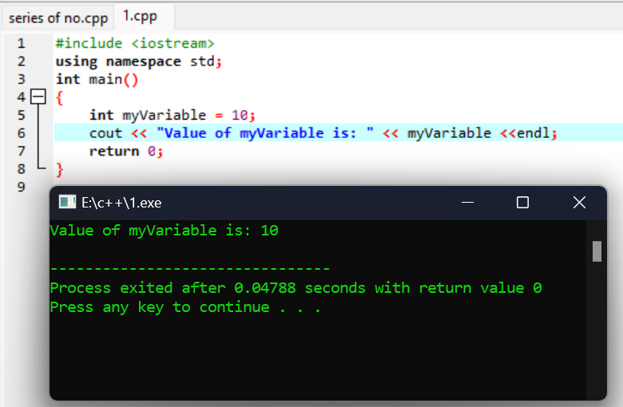

7.Write a c++ code for swapping of two numbers .

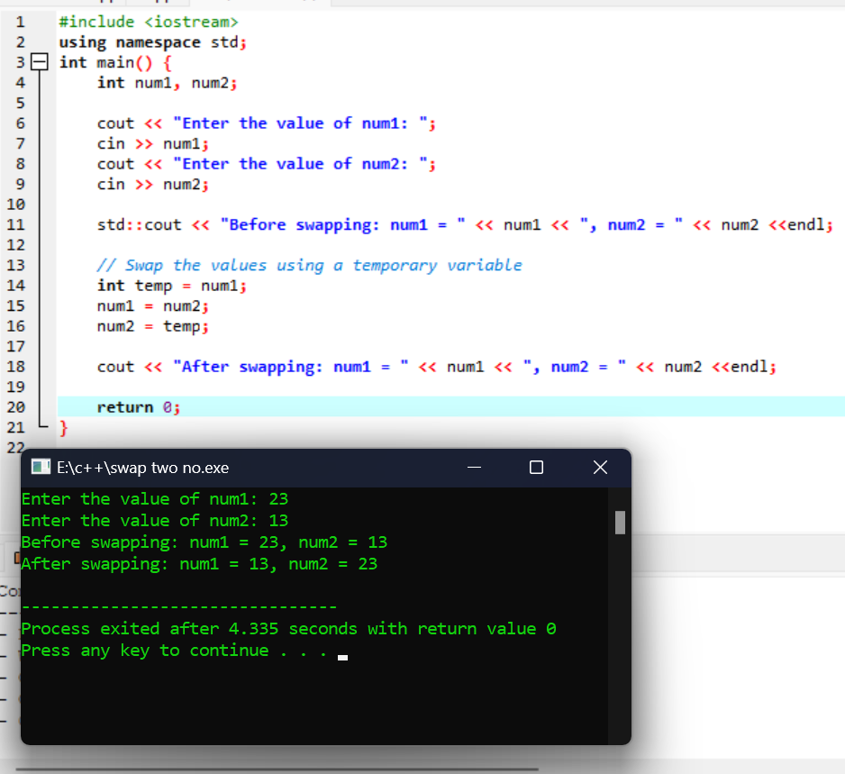

8.Wrapping data and its related functionality into a single entity is known as _____________Encapsulation  
a) Abstraction  
b) Encapsulation  
c) Polymorphism  
d) Modularity

Answer: B

9. What happens if the following program is executed in C and C++?

#include<stdio.h>

int main()

{

foo();

}

int foo()

{

printf("Hello");

return 0;

}

Error in both C and C++  
b) Warning in both C and C++  
c) Error in C++ but Warning in C  
d) Error in C but Warning in C++

Answer: c  
Explanation: In C++ all the functions should be declared before it is called otherwise the C++ compiler will give an error but in case of C the compiler just gives a warning and the program can be executed.

10. Write a C++ code to area of circle and area of rectangle.

AREA OF CIRCLE:

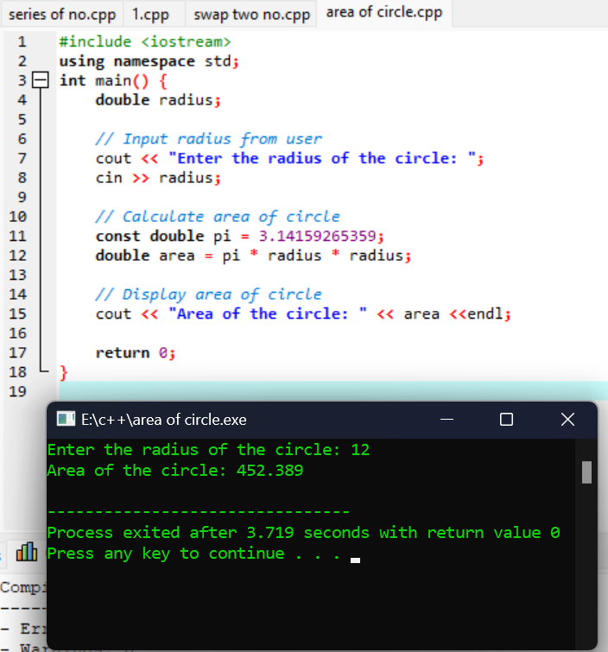

AREA OF RECTANGLE:

